Q:1 What is the IP address and TCP port number used by the client
computer (source) that is transferring the file to gaia.cs.umass.edu?
->The source and port number use by client is…
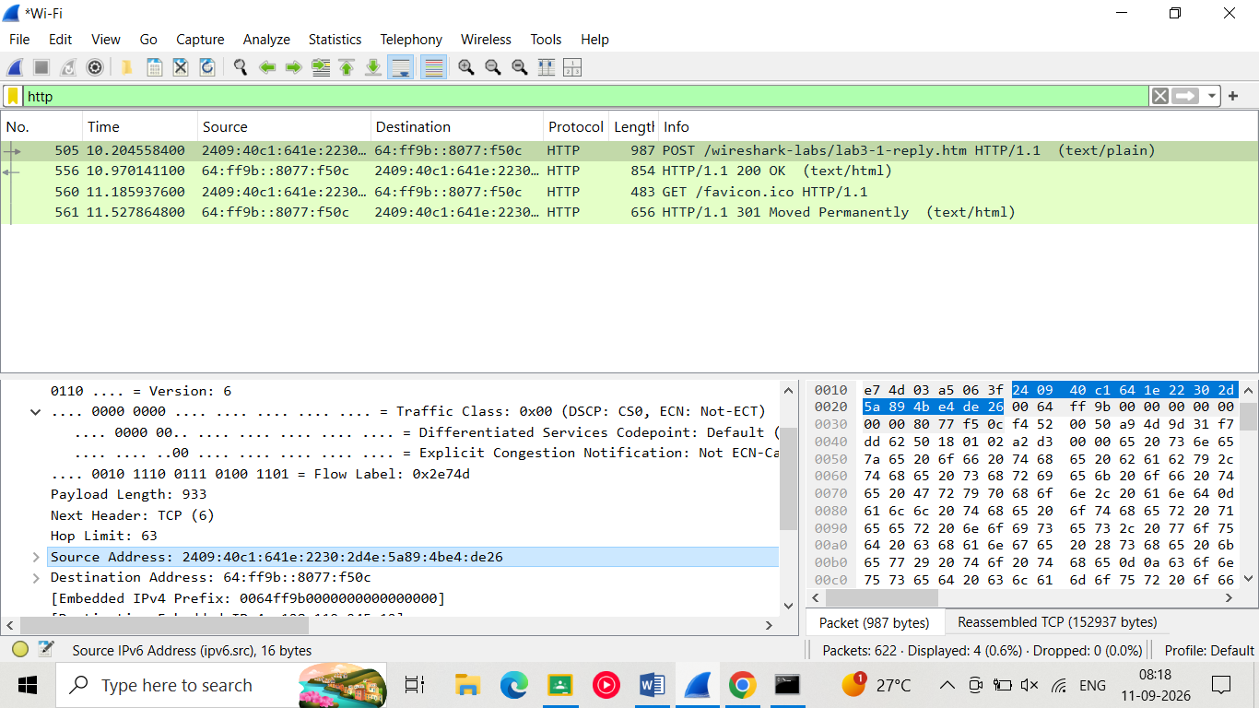
- Source port:
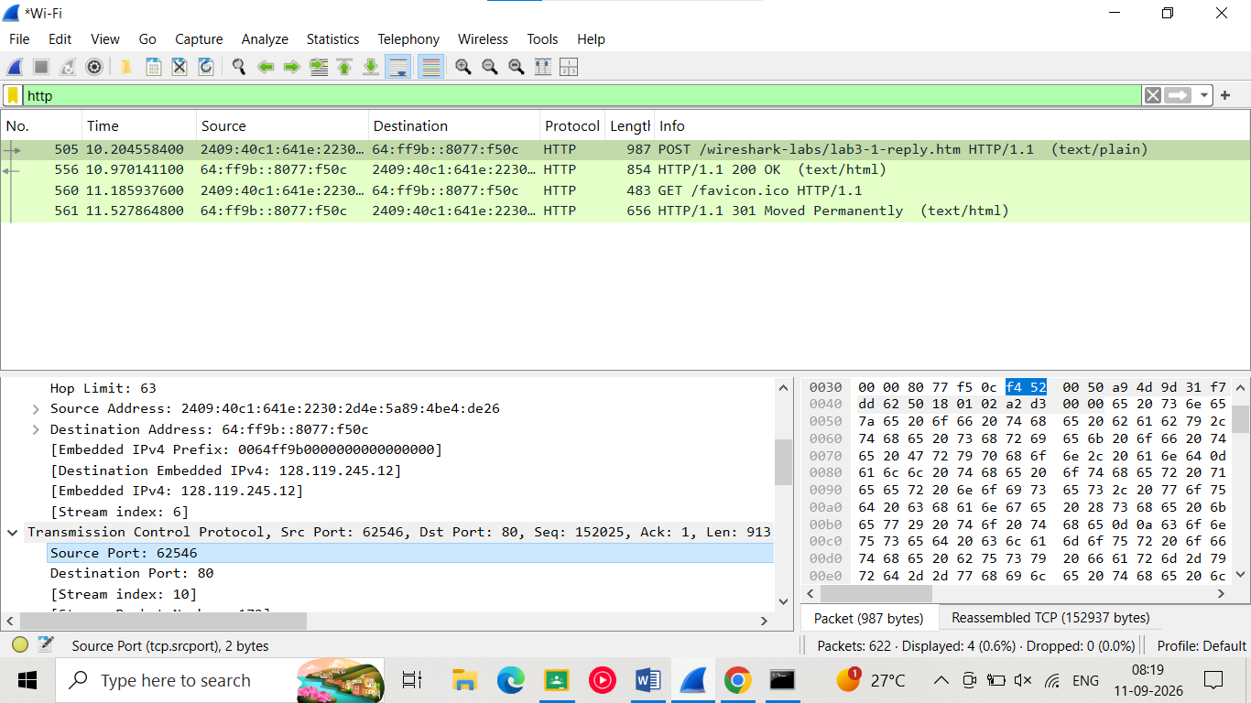

Q:2 What is the IP address of gaia.cs.umass.edu? On what port number
is it sending and receiving TCP segments for this connection?
- The destination ipv6 is …..
- 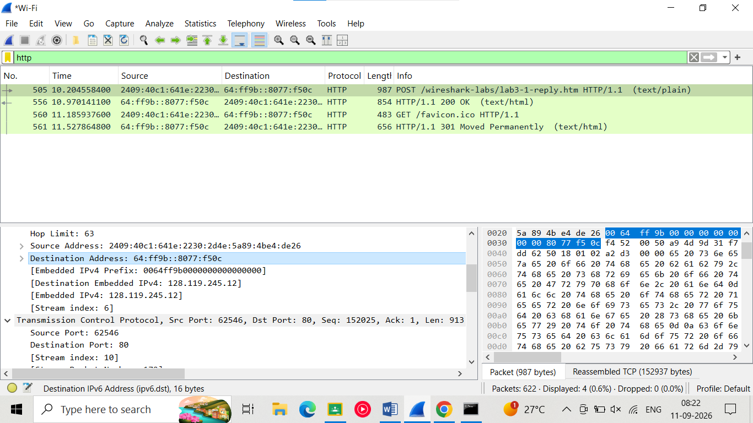

- The destination port is….

- 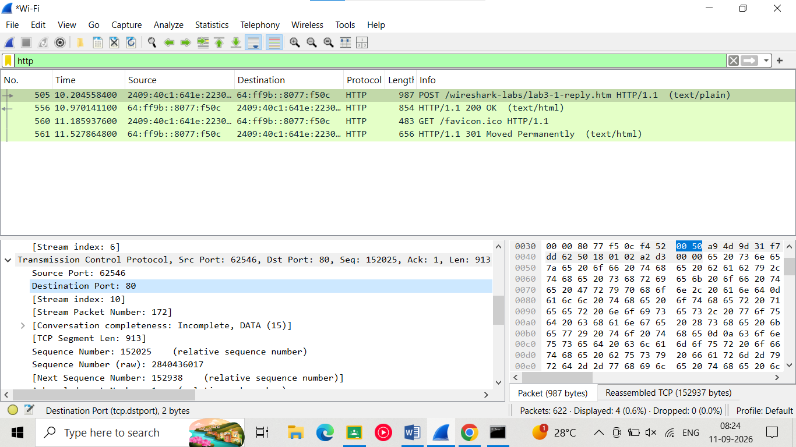

Q:3 What is the IP address and TCP port number used by your client computer (source)
to transfer the file to gaia.cs.umass.edu?

Q:4 What is the sequence number of the TCP SYN segment that is used to initiate
the TCP connection between the client computer and gaia.cs.umass.edu? What
is it in the segment that identifies the segment as a SYN segment?
(match this things for selecting a syn packet, this are present in http post packet)
Ip of server: 128.119.245.12
source port :54851 (this is client port num)
Destination port :80 (this is server port num)
->sequence num:0
->Flags: 0x002 (SYN)
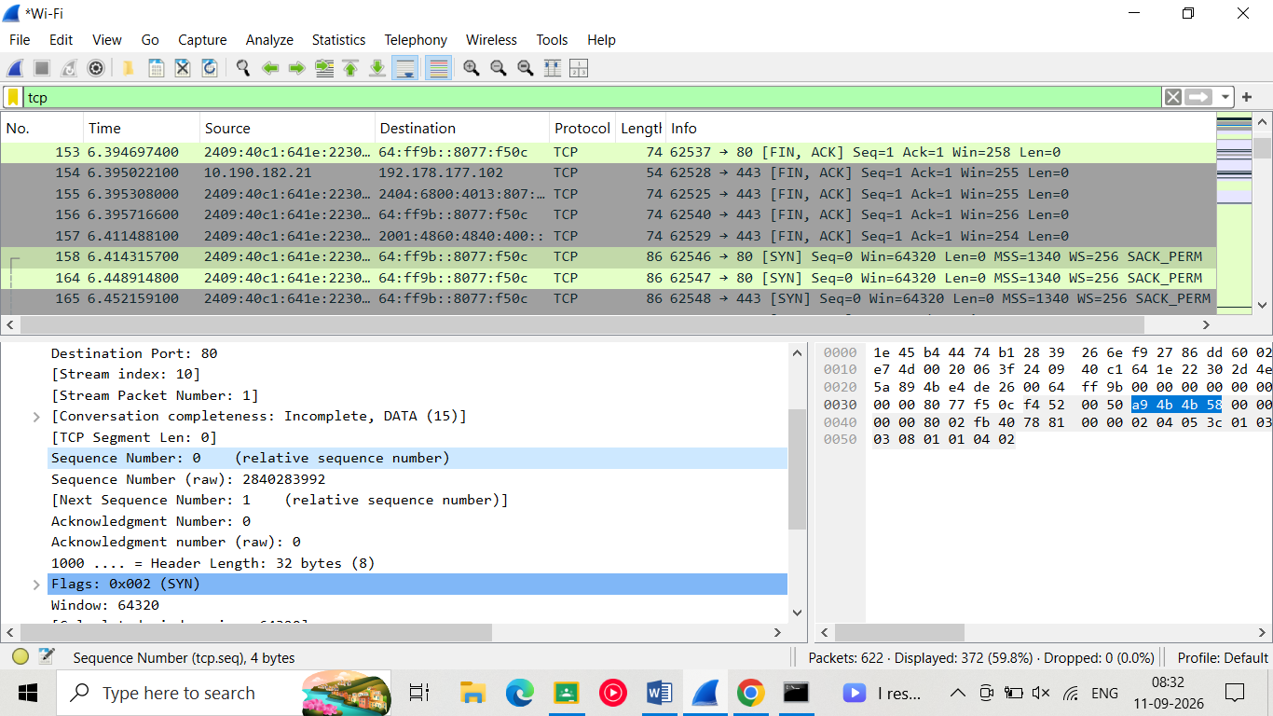

Q:5 What is the sequence number of the SYNACK segment sent by
gaia.cs.umass.edu to the client computer in reply to the SYN? What is the value
of the Acknowledgement field in the SYNACK segment? How did
gaia.cs.umass.edu determine that value? What is it in the segment that identifies
the segment as a SYNACK segment?

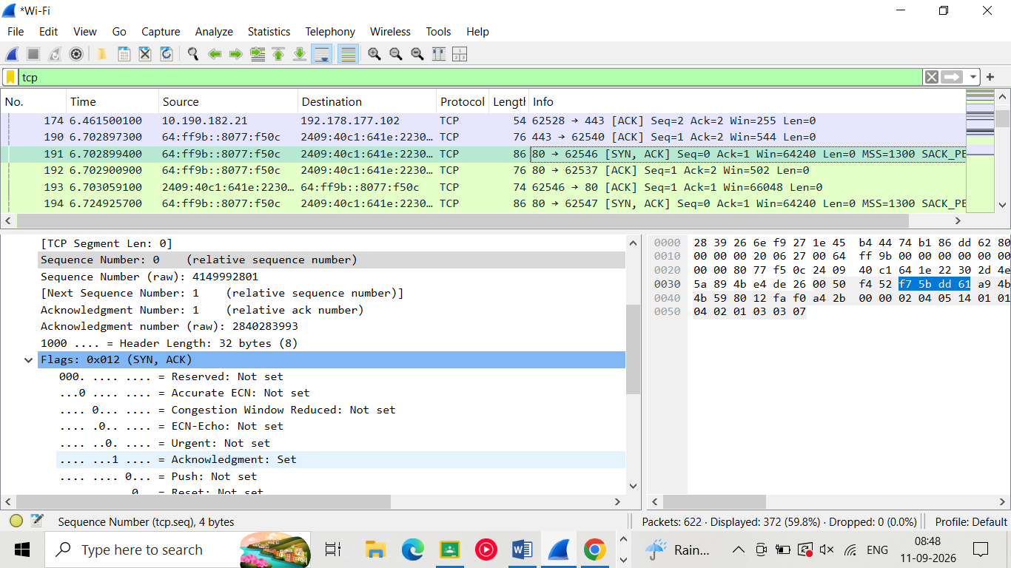

Q:6Find the TCP packet that contains the HTTP POST command. What is its Sequence
Number?
To find the HTTP POST command, find the packet whose Data field contains the word
"POST".

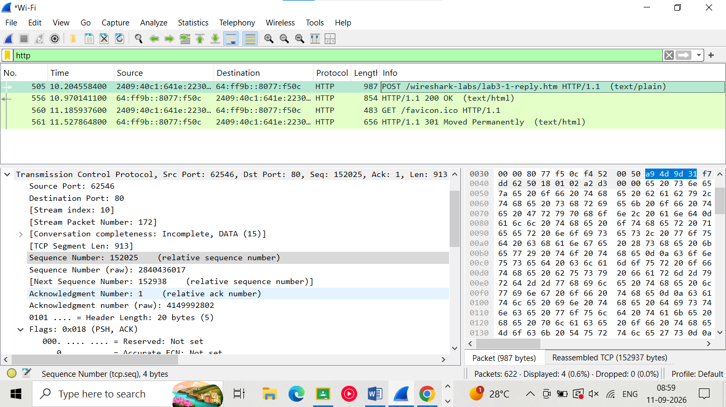

Q:7 What is the length of each of the first six TCP segments?

